
https://faureherman.com/

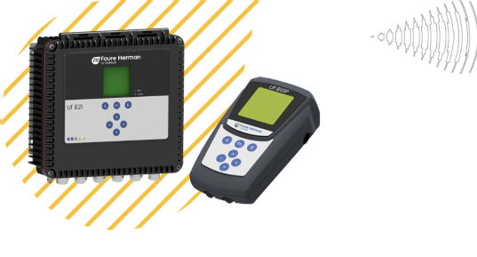
Ultrasonic Flowmeter (UF 800 Product line)
UF 800 product line has a very wide measurement spectrum and applications. Either fixed or portable configuration.
Up to 10 meters diameter, up to 8 chords. Last but not least available for open channel and full pipe.
In combination with large transducers external clamp-on or insertion or open channel.

Helical Turbine Flowmeter
(Heliflu®-TZN)
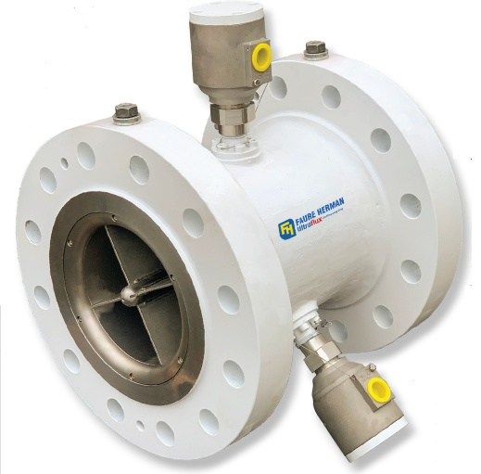
Heliflu®-TZN features a more advanced rotor for superior performance and reliability. It offers you limited downtime and disruption of service. Cartridges can generally be replaced in under an hour.
Its superior repeatability makes it the ideal solution for Master Meters!

KEY BENEFITS
- Custom calibrated to your specified viscosities
- Suitable for high viscosities (greater than 350 cSt)
- Minimal sensitivity to density and viscosity variations
- Superior linearity & repeatability over wide flow ranges
- Addresses production life cycle changes: — Downsizing “DS” & Flexible Flowrates “FF”
- Low pressure drop and lower energy consumption
- Low downtime — customer serviceable
- Easy to prove — ideal solution for Master Meters
- Superior pulse stability reduces required prover volume
- Proven robust technology / Long term reliability
- Complies with global certifications and standards
- Faure Herman’s 90+ years of metering experience

PRODUCT APPLICATIONS
- Custody transfer measurement
- Pipeline measurement
- Marine terminal
- Tanker loading/offloading
- Master metering
- Storage management
- FSO & FPSO metering
- Leak detection
- Oil production allocation

The Heliflu™ TLM flowmeter is designed for high accuracy measurement of low to medium viscosity liquids and refined products.
Meter installations and custody transfer operations are improved by the unique weight and space saving design which includes integrated flow conditioning.
The Heliflu™ TLM is fitted with a removable measuring cartridge and includes an integrated flow conditioner that allows installation without any upstream and downstream pipe runs.
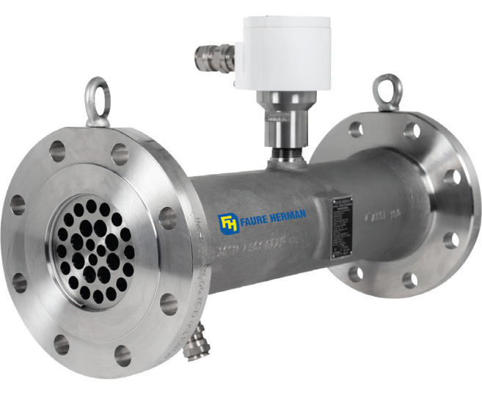
Product applications
Storage
Airport refuelers
Wagon & road tankers
Loading racks
Light products transfer
Master metering

